Decision Tree Theory
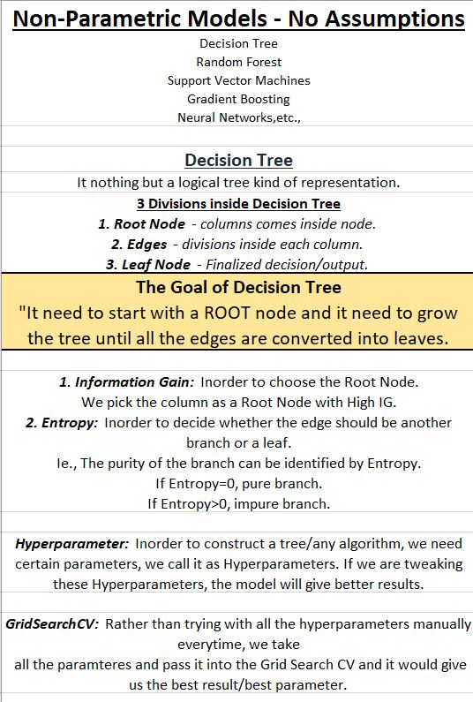

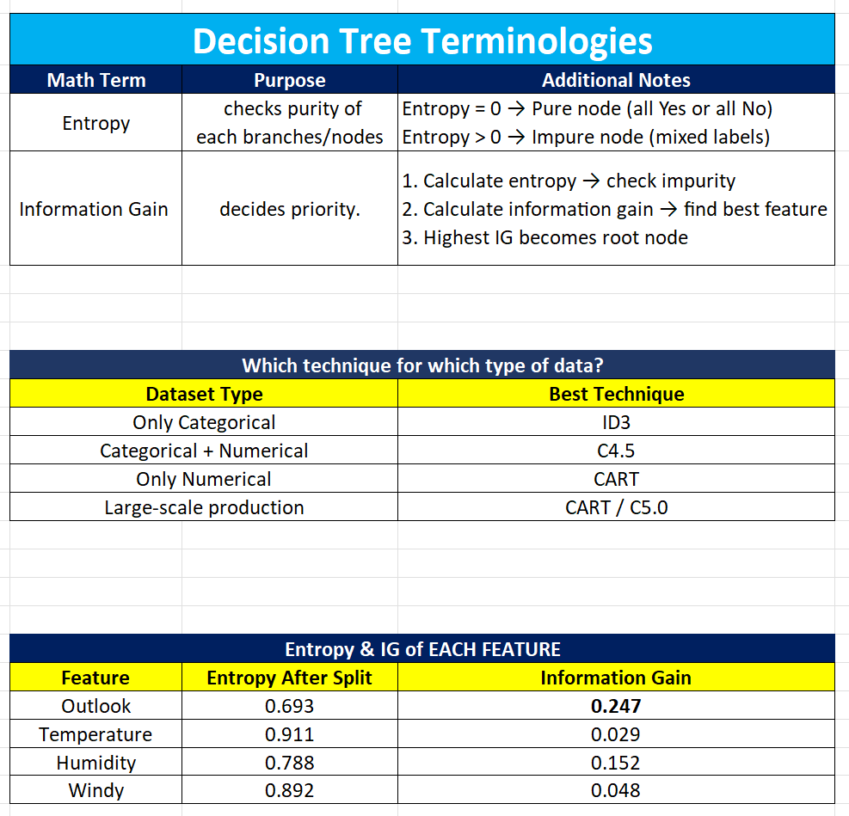
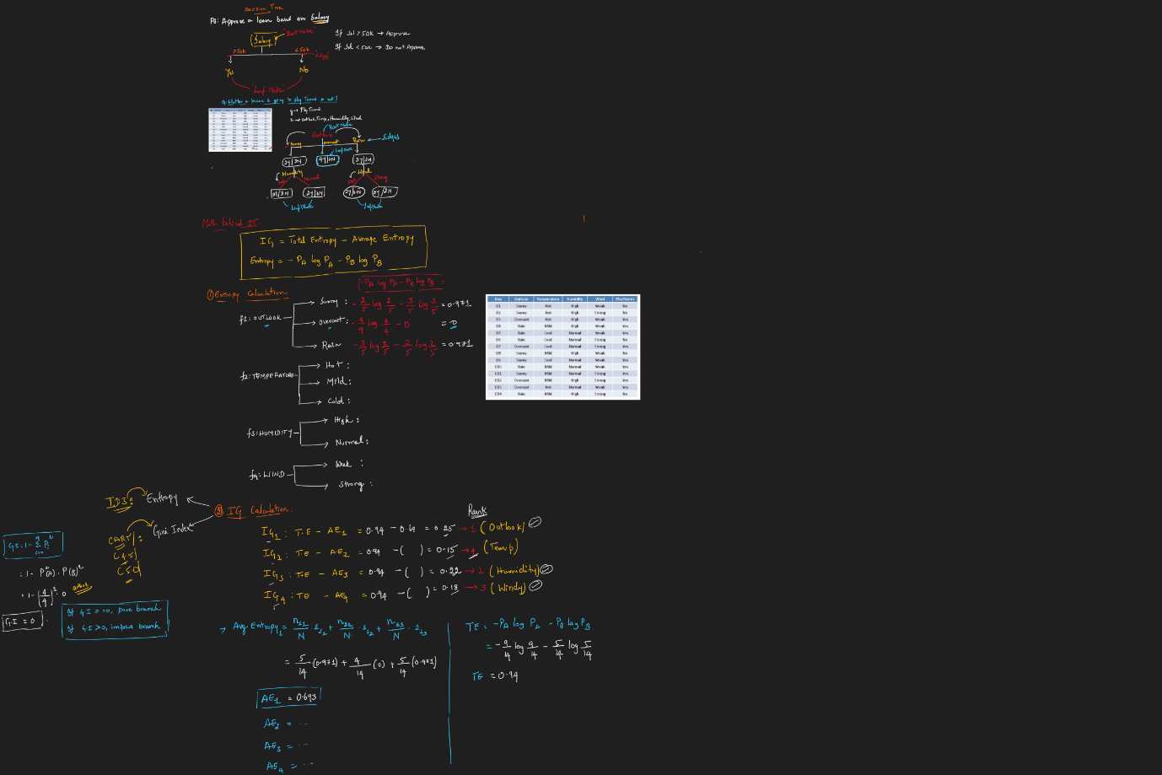

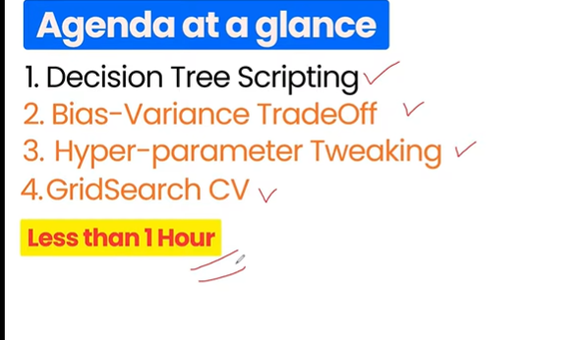

For binary classification Entropy + ID3 Technique can be used
But, when multi classification like apart from yes or no, there can be possibility 0,1,2
So this time we can use gini index.
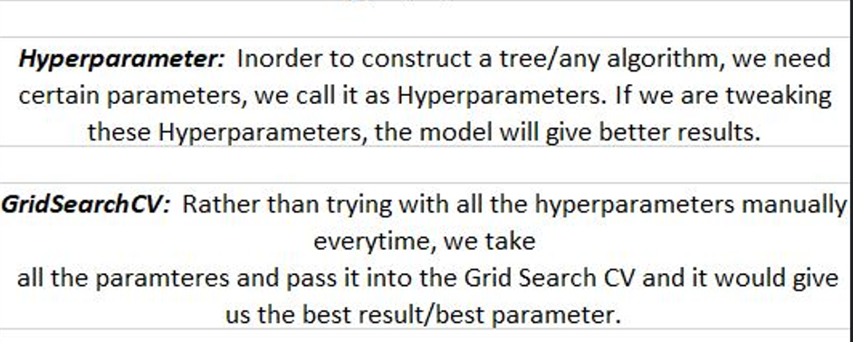

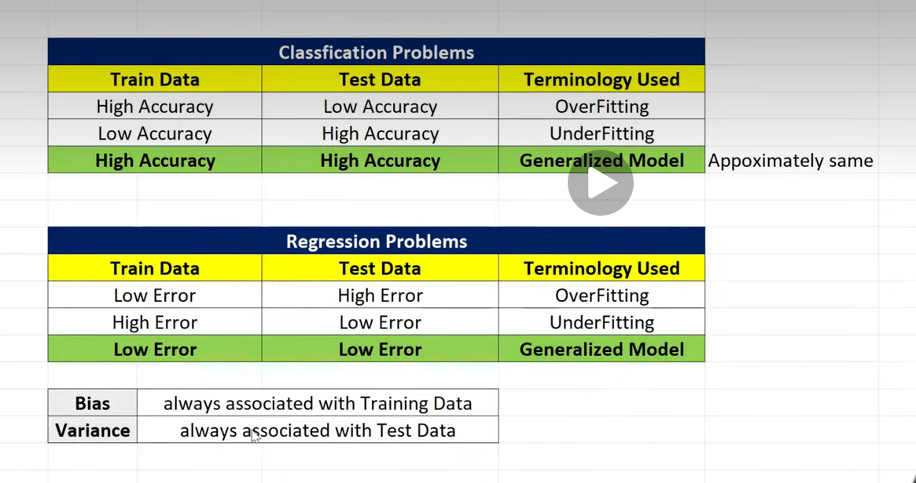
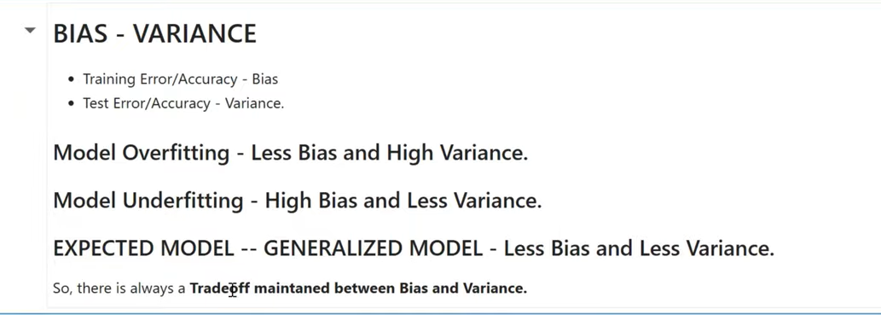

My understanding about Decision Tree:
Root node selection:
At the start, the algorithm calculates Information Gain (IG) (or Gini reduction) for each feature. The feature with the highest IG becomes the root node.
✅ Binary split: That feature is split into two groups (e.g., “≤ threshold” vs “> threshold” for numeric, or “Yes/No” for categorical).
✅ Recursive splitting:
- On the left branch, if the target values (Y) are mixed, the algorithm again checks all remaining features and picks the one with the highest IG.
- This continues until the branch becomes pure (all Y are the same) → that’s a leaf node.
✅ Right branch: Once the left side is finished, the algorithm does the same process on the right side.
✅ Traversal for prediction: When you give new input, the algorithm simply walks down the tree by answering each split condition until it reaches a leaf, and then outputs the prediction stored there.
Why Pruning is Needed
If we let the tree grow without limits:
- It will keep splitting until every leaf is pure (all Yes or all No).
- That means the tree memorizes the training data → overfitting.
- Overfitting = great accuracy on training data, but poor accuracy on new/unseen data.
✂️ Types of Pruning
- Pre-pruning (early stopping)
  - Stop splitting when certain conditions are met:
    - max_depth (limit tree height)
    - min_samples_split (don’t split if too few samples)
    - min_samples_leaf (each leaf must have enough samples)
  - Example: If a branch has only 2 samples, don’t split further.
- Post-pruning (after full growth)
  - Grow the full tree first.
  - Then cut back branches that don’t improve performance (using validation data or cost-complexity pruning).
  - In sklearn, this is controlled by ccp_alpha (complexity parameter).
Imagine a dataset where:
- At depth 4, a split separates 1 “Yes” from 1 “No”.
- That split perfectly fits training data, but it’s just noise.
- Pruning would remove that split and keep a simpler rule, improving generalization.
What is Entropy?
entropy is the mathematical way of measuring uncertainty or impurity in a dataset. Let me break it down clearly.
In information theory, entropy tells us how “mixed” the data is.
If all outputs (Y) are the same (all Yes or all No), entropy = 0 → pure.
If outputs are evenly split (50% Yes, 50% No), entropy is maximum → most uncertain.
$$Entropy\left(S\right)=-\sum_{i=1}^{c}{p_{i}}⋅\log_{2}\left(p_{i}\right)$$
- $c$= number of classes (e.g., Yes/No → 2 classes)
- $p_{i}$= proportion of samples in class $i$
Example
Suppose we have 6 samples: 3 Yes, 3 No.
- $p_{Yes}=3/6=0.5$
- $p_{No}=3/6=0.5$
$$Entropy=-\left(0.5⋅\log_{2}\left(0.5\right)+0.5⋅\log_{2}\left(0.5\right)\right)=-\left(0.5⋅-1+0.5⋅-1\right)=1.0$$
Maximum entropy = maximum disorder.
Now suppose all 6 are Yes:
- $p_{Yes}=1.0,p_{No}=0.0$
$$Entropy=-\left(1⋅\log_{2}\left(1\right)+0⋅\log_{2}\left(0\right)\right)=0$$
👉 Entropy = 0 means pure (no uncertainty).

What happens when we prune with max_depth
- Tree building phase: Normally, the algorithm keeps splitting until leaves are pure. But if you set max_depth = 2, for example, the tree is forced to stop after 2 levels, even if further splits could reduce impurity.
- Leaf nodes after pruning: Since the tree stops early, some leaves will still contain a mix of Yes and No samples. Instead of splitting further, the algorithm assigns a prediction based on the majority class (classification) or the average value (regression).
Prediction after pruning
When you give new input:
- The algorithm traverses the tree as usual, following conditions until it reaches a leaf.
- If the leaf is pure → prediction is straightforward (all Yes or all No).
- If the leaf is mixed (because pruning stopped early) → prediction is based on the distribution of samples in that leaf:
  - Classification: majority vote (e.g., 70% Yes, 30% No → predict Yes).
  - Regression: mean of values in that leaf (e.g., house prices [70, 80, 90] → predict 80).
Key Insight of Prune
Pruning doesn’t change how prediction works — it just simplifies the tree.
- Traversal is the same.
- Leaves may be mixed, but prediction is based on majority/average.
- This makes the model smaller, faster, and more generalizable.

How the Root Node Threshold is Chosen
- Candidate thresholds
  - For a numeric feature (say Income), the algorithm sorts the values.
  - It then considers thresholds between consecutive unique values.
  - Example: If Income values are [30,000, 40,000, 60,000, 70,000, 80,000, 90,000], candidate thresholds are midpoints like:
    - (30,000 + 40,000)/2 = 35,000
    - (40,000 + 60,000)/2 = 50,000
    - (60,000 + 70,000)/2 = 65,000
    - … and so on.
Evaluate each threshold
- For each candidate split (e.g., Income ≤ 50,000 vs > 50,000), the algorithm calculates impurity (Entropy or Gini) of the resulting groups.
- It computes Information Gain = reduction in impurity compared to the parent node.
Pick the best threshold
- The threshold with the highest Information Gain becomes the split.
- That feature (Income, Age, or CIBIL) with its chosen threshold becomes the root node.

